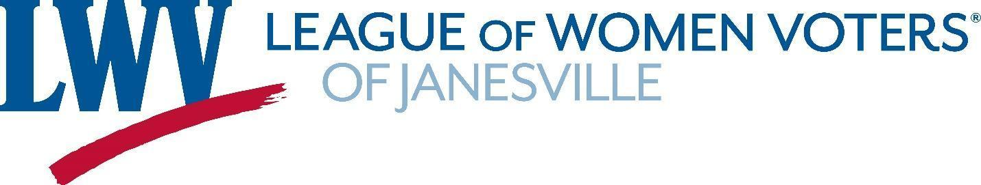
Membership Form 2020-2021

Please fill out this form completely to ensure we have current information. Dues and forms are due by JUNE 30 of each year. You may choose to pay dues online with Paypal at https://www.lwvjvl.org/join-the-league. If you pay online, please provide the following information in the online survey form. Thank you.

CONTACT INFORMATION

Name _________________________________________________ Preferred Phone No. _____________________

Address _______________________________________ City______________________ State ____ Zip _________

Email ___________________________________________

MEMBERSHIP CATEGORIES

$65 Active Membership | For each Active Member, our League is assessed $32 National dues and $30 State dues. $3 remains in Janesville.
$70 Supporting Membership | Supporting Members are not called upon to serve on committees or working groups.
$100 Active Household Membership | Our League is assessed $16 (National) and $15 (State) for an additional person within a Household.
$ ____ Open Door Membership | Members pays dues they are comfortable with. Our League is not assessed State dues for members in this category.
$10 Student Membership | No National or State dues for high school and post-secondary students

For Household Membership:
Name of additional member ___________________________________________________________________

Email ______________________________________________________ Phone # ________________________

If you wish to make a donation to support the LWV-JVL, please indicate the amount and include in your check:

Dues: _____________ + Donation: _____________ = Total Amount Due: ______________

Please make checks payable to the LWV-Janesville and mail with completed form to LWV-Janesville, PO Box 8064,
Janesville, WI 53547-8064.

Dues are important, but your involvement in the League’s work is what will make us a vital community organization. If you have selected an ACTIVE member status, please circle one or more interest areas below:

Voter Education & Services | Diversity, Equity and Inclusion (DEI) | Publicity and Social Media
Homelessness and Affordable Housing | LWV Luncheon | Fundraising
Membership | Observer Corps | Natural Resources

